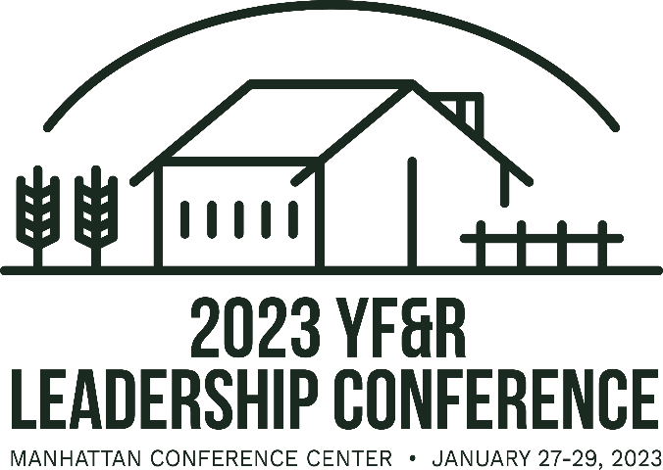
Registration Information Collection Form for Counties

No paper registration forms will be accepted by KFB. This form exists to help County Coordinators collect attendees’ registration information only.

Attendee Type:
___ Member ___ Non-Member ___ Collegiate Farm Bureau Student
___ Ag Ambassador ___ Collegiate Adviser ___ County Coordinator
First Name: Last Name:
(Please enter name as you would like it to appear on their name badge)
Email: ___________________________________________________________________
T-Shirt Size: __ S __ M __L __ XL __ 2XL __ 3XL
District: ________________ County: ____________________________________
Is this your first time attending the Kansas YF&R Leaders Conference? ___ Yes ___ No
Please mark the meals you plan to attend:
___ Friday Collegiate Lunch ___ Friday Evening Reception & Kick-off
___ Saturday Eggs & Issues Breakfast ___ Saturday YF&R Networking Lunch
___ Saturday District Dinners ___ Sunday Breakfast by Chris Cakes

Please list dietary restrictions: ____________________________________________________________________

If you plan on bringing your children that need meals/seat, how many do you intend on bringing? _________ ($50/child for meals)

*Your registration does not include lodging* Please make separate arrangements through the room block list on the KFB website (www.kfb.org/article/YFR-Leaders-Conference)

