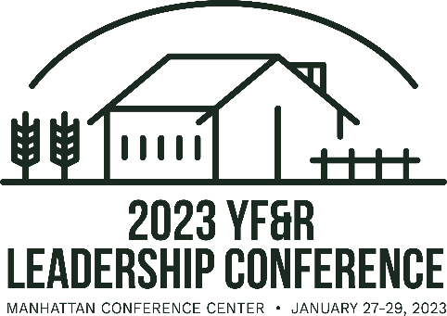
2023 YF&R Conference Step-by-Step Registration Process for Collegiate Advisors

- Ask your chapter members who would like to attend YF&R Conference and collect their information using the “Registration information Collection Form 2023” that can be found at https://www.kfb.org/Article/YFR-Leaders-Conference.

- Input all the information from the attendees on the registration website https://shop.kfb.org/product/yf-r-registration/35 by January 4^{th.} (late registration extends until Jan 16 and students don’t have a late fee)

- If you are choosing to pay for your chapter members in full, then proceed with payment online once your attendees information has been added.
  - If you would like to use the KFB Foundation Grant to pay for collegiate members, use the coupon code sent to you via email from YF&R and Collegiate Manager, Janae. Grants will not be given out post-conference, you are responsible to use the code for payment.

- Once registration is complete, make sure to book hotel rooms for attendees at one of the three room blocks around Manhattan. Those room block information can be found here https://www.kfb.org/Article/YFR-Leaders-Conference.

- Encourage students to sign up for Collegiate Competitions at the YF&R Conference including Discussion Meet and Quiz Bowl. All applications can be found on https://www.kfb.org/Get-Involved/Contests-Recognition. Applications must be submitted by January 14.

