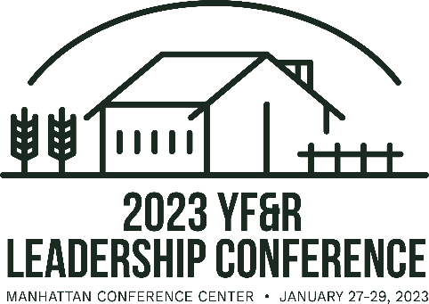
2023 YF&R Conference Step-by-Step Registration Process for County Coordinators

- Ask your county members who would like to attend YF&R Conference and collect their information using the “Registration information Collection Form 2023” that can be found at https://www.kfb.org/Article/YFR-Leaders-Conference.

- Input all the information from the attendees on the registration website https://shop.kfb.org/product/yf-r-registration/35 by January 4th (any after January 16th will incur a $25 late fee)

- If you are choosing to pay for your county members in full, then proceed with payment online once your attendees information has been added.
  - If you would like to use the KFB Foundation Grant to pay for 10 of your county members, use the coupon code sent to you via email from YF&R Manager, Janae. After the 10 members of your county have used the discount, you will be responsible for the full registration rate for any additional members.

- Once registration is complete, make sure to book hotel rooms for attendees at one of the three room blocks around Manhattan. Those room block information can be found here https://www.kfb.org/Article/YFR-Leaders-Conference.
- Encourage attendees to sign up for YF&R or Collegiate Competitions at the YF&R Conference including Discussion Meet, Quiz Bowl, Excellence in Agriculture or YF&R of the Year. All applications can be found on https://www.kfb.org/Get-Involved/Contests-Recognition. Applications must be submitted by January 14.

